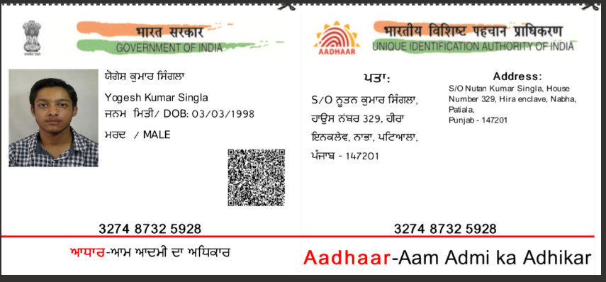

Video link :https://methodhubindia-my.sharepoint.com/:v:/g/personal/anjali_sagar_method-hub_com/EWvlWfGpZO9OpYJdzZnePQwB1PDYBTCzWsVhsadoxZiKeA

Yogesh Kumar Singla
ersinglayogesh@gmail.com | +1 (613) 869 7871

EDUCATION

UNIVERSITY OF OTTAWA

Master of Systems Science and Engineering
2022-2023 | Ottawa, Canada

PUNJABI UNIVERSITY

B.Tech in Computer Science and Engineering
2015-2019 | Patiala, India
University College of Engineering

LINKS
Github:// singla007
LinkedIn:// yogesh-kumar-singla CodeChef:// yogesh007 Kaggle:// yogeshkumarsingla Datacamp:// yogeshsingla

COURSEWORK

GRADUATE
Full Stack Cloud Development) Foundation Modelling and Simulation System Optimization and Management Data science applications
OOP using C++
System Design and Analysis Data Structures
RDBMS using PL/SQL Artificial Intelligence

SKILLS

PROGRAMMING
Over 5000 lines:
Java • C++ • Python • Javascript
Over 1000 lines:
C • Scala • SQL • MatLab
Frameworks:
Scikit • TensorFlow • Keras • openCV • FLAML • Docker • Auto-Sklearn • Flask • Django • XgBoost • Airflow • Azure Databricks • AutoML • Next.js
Tools:
Hadoop • Apache Spark • Hive • Pig • Jupyter Notebook • Anaconda • Visual Studio Code • Tableau • Pycharm
Clouds:
Azure • AWS • GCP
Soft Skills:
Problem Solving • Time Management • Stress Management

EXPERIENCE
CIOS, CANADA | Software Developer Intern
SubletConnect | Mar 2023 - Apr 2023 | Ottawa, Canada
- Successfully configured and deployed CI/CD using AWS, Jenkins for a complex end-to-end website project, improving the development workflow and ensuring high-quality code delivery.
- Contributed to bug fixing and full-stack development using modern
technologies such as React, Node.js, and MongoDB, enhancing the project’s functionality and user experience.
UNIVERSITY OF OTTAWA | Software Developer Intern
XR-Climate change | Jan 2023 - Feb 2023 | Ottawa, Canada
- Configuring and deploying servers to manage data and API’s with proficiency in
Postgres for designing and implementing database schemas.
- Implementing scalable architecture using Docker to manage a high volume of requests, optimizing system performance by conducting testing and optimization of the database.
INFOSYS | Senior Software Developer
Sweeetgreen Project | Jan 2022 - Aug 2022 | Pune, India
- Developed a Machine Learning-based recommendation system for product suggestions by leveraging collaborative filtering, content-based filtering, and deep neural networks.
- Implemented data pipelines using Azure data services, PySpark, and Apache Airflow to extract, transform, and load data from diverse sources.
Infosys Internal Project | Sep 2019 - Sep 2021 | Pune, India
- Worked on Infosys Data Science and ML Tool to streamline data analysis and modeling for the organization.
- As a Data Scientist, responsible for data preparation including wrangling, cleaning, and preprocessing for modeling. Designed and developed the AutoML solution for the tool.
- Utilized NLP techniques and BERT model for data preprocessing, cleaning, entity linking, and named entity recognition.
INFOSYS | Software Developer Intern
Jan 2019 - May 2019 | Mysore, India
- Completed Full-stack developer training, where I gained expertise in
technologies such as React, Node.js, SQL, HTML, CSS, Django, and Bootstrap.
- I worked on a project to create a Social Media platform using the knowledge acquired from the training. I also used agile methodologies such as Scrum to manage the project, and collaborated with a team of developers.

CERTIFICATIONS
APR 2022 Azure Certified Azure Data Scientist Associate Jun 2020 Udacity Natural Language Processing Nanodegree May 2020 Udacity Deep Learning Nanodegree

AWARDS
2021 1st/Unit Infosys Unit level hackathon
2020 Project Insta Award for outstanding contribution in Infosys project 2019 4th/50,000 Infosys Hackathon organised by ABN Amero
2018 top 150/India Huawei ICT competition

